Report on the Faith and Blue Lights Conference, Wednesday 18th October 2023 in Chelmsford Cathedral

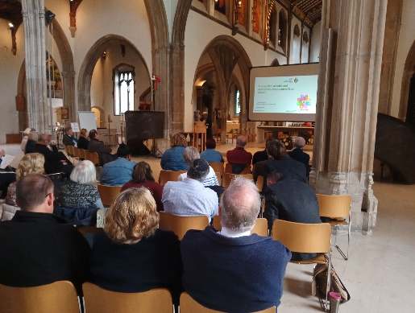
On Wednesday October 18th 2023 the Essex Faith Covenant (EFC) in conjunction with Essex Mind and Spirit (EMS) staged the first ever Faith and Blue Lights conference at Chelmsford Cathedral. It proved to be an extraordinarily effective and well received event, bringing together the police, fire and ambulances services, caring agencies and various faith communities under one roof, to explore issues including race/hate crime, community resilience and the role of faith communities in partnership with the emergency services in engagement for the common good and in the event of future community crises management. As such it was probably the biggest set piece event demonstrating the principles of the EFC to bring faith communities and public services together for mutual dialogue, cooperation and joint working. And the various faith communities present appreciated the chance to hear directly from the police, fire and ambulance services why this conference was important to them, the importance they placed on the role of faith communities and what they can contribute to the common good and how each of the services was seeking to reflect this in their policies and procedures. (Of particular interest was the recent formation of a new Chaplaincy service for the East of England Ambulance Service, and their urgent, much needed task of ‘caring for the carers’).

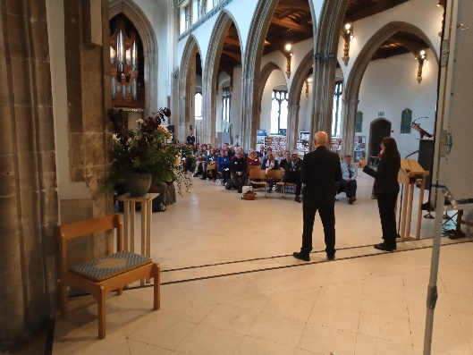
When the conference was being planned, little could we have foreseen the terrible events now unfolding in the Middle East, but which gave the conference a very specific and acute relevance and significance. Two of our keynote speakers, Iman Atta and Colin Tourick were representing organisations which were responsible for keeping Muslims and Jews safe in the face of an alarming rise in anti-Islamic and anti-Semitic hate attacks- Tell MAMA and the Jewish Community Security Trust. Both gave insights into their work and some frightening statistics about the rise in religious and race hate crime against their religious communities, but a real highlight of the conference was when, after a time for questions, Colin and Iman embraced each other which brought huge gratitude and applause from the conference delegates. Somehow that embrace summarised why a conference like this was proving so important; that despite all our differences, we had come together to recognise what unites us rather than what divides us, and that the care and concern for our various communities is a shared common cause and task for all of us.
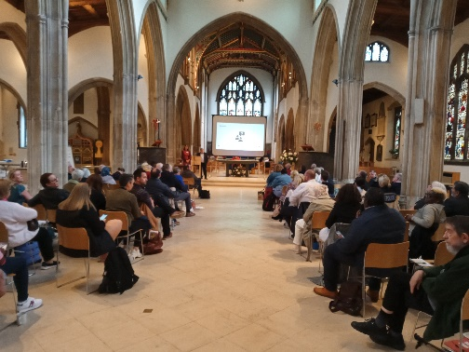
Our keynote speaker in the afternoon, Sulafa Abushal, built on the foundations laid by our morning speakers, describing how she as a member of the Greater Manchester
Resilience Unit works to build healthy, cohesive, resilient communities encouraging their ability to contribute to emergency preparedness, response and recovery, and through inter faith partnerships to understand better how resilience is a whole society endeavour.

All of this prepared the delegates well for the various workshops which explored aspects of what they had heard and seen. Ranging from a police workshop on race and hate crime, to combatting neglect and promoting effective safeguarding, to working together to understand and combat the scourge of modern slavery, to effective and informed multi-faith contributions to future corporate crises (like COVID-19 and the pandemic and lockdowns) and working with the police and emergency services to understand different rituals and approaches to bereavement and breaking bad news.

Finally, the mark of any good conference, in the end, is not just the provision of good, relevant and interesting material for delegates to consider, but the opportunities provided for effective and widespread networking. Aided by a superb lunch provided by Brian Greatrex and his cathedral team, conversations were begun and continued between people and organisations which probably wouldn’t have happened had it not been for the tenure and output of the conference, and the environment and hospitality of the cathedral which was key to the facilitation of that process. The faith and Blue Light Conference was an example of what cathedrals do and what they are for; meeting places and crossing points, big enough to accommodate differing opinions and perceptions, welcoming enough to make people feel comfortable and at home, and challenging enough to help people find and pursue common ground.

And where do we go from here? Well….there was widespread agreement that we mustn’t stop there: another conference at some point is a distinct possibility, and all the delegates have been asked to return a questionnaire to the EFC to see where and how it might be able to take forward and develop this work

Watch this space….!

Ivor Moody, Vice Dean and Canon Pastor of Chelmsford Cathedral, and Chair of the Essex Faith Covenant, and Chair of Essex Mind and Spirit.

